CSCE 438 HW 3.2 Design Document

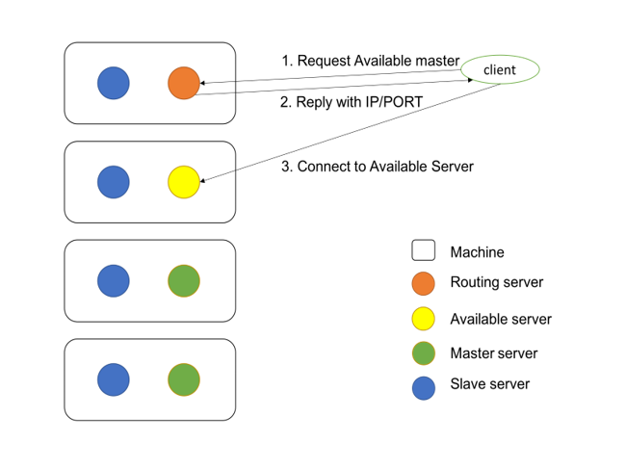

* Routing server will always be started on first machine, with IP 10.0.2.15 at port 16666. All server will be listening on port 16666 at whatever IP address they may be on.
* When each server starts up, they will connect to routing server and add their IP and port number to the routing server database.
* When clients connect to routing server (default hostname and port argument on tsc startup), they will be redirected to an available server for processing their requests. They will also be assigned an alternate master server that acts like a backup master.
* In order to preserve data consistency, the clients also get a followed list. This is the following/followed list based off of sessions from last connection since they are not stored w/ every startup
* If a server crashes, then the client will detect this, and will be redirected to the next available server: the slave it was assigned to. Client will alternate between these two. The routing server will be notified of this
* If a server crashes, a slave server will restart the master server.
* Timestamps are handled based off of the routing server’s main time in order to account for differences between masters and clients.